**Task 2: Geospatial Public Transportation Tracker**

The Johannesburg Geospatial Public Transportation Tracker, a state-of-the-art web-based application crafted to revolutionize how to navigate public transportation in Johannesburg. This powerful tool enables users to effortlessly track and view Johannesburg public transportation routes, schedules, and real-time vehicle locations. By leveraging the capabilities of the Google Maps API, our application provides a seamless mapping experience for routes and vehicle locations. Additionally, it integrates seamlessly with various public transportation APIs to ensure you have access to the most up-to-date route data and schedules. Whether you're planning your daily commute or exploring the vibrant city of Johannesburg, the Geospatial Public Transportation Tracker is your reliable companion for all your transit needs.

**Google Maps JavaScript API key from the Google Cloud Platform.**

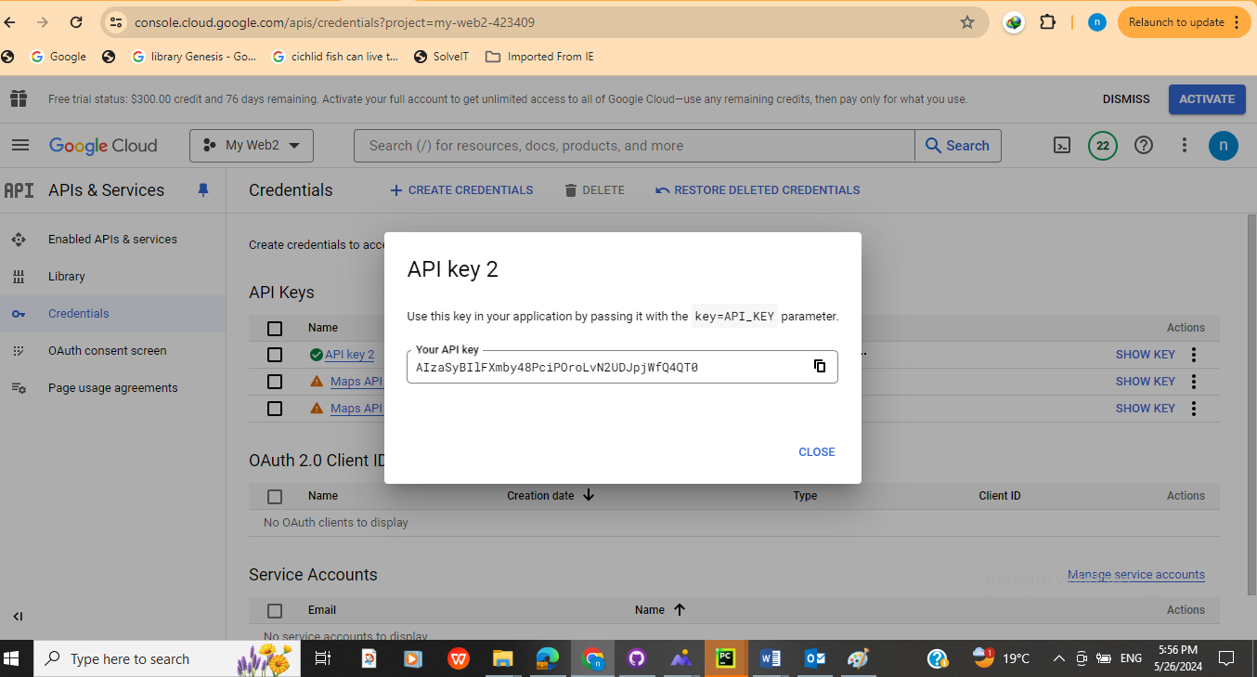

**Data Integration using APIs**

APIs needed to gather real-time data for public transportation in Johannesburg:

Obtain access to public transport APIs that provide information such as schedules, routes, vehicle locations, and updates.

Examples:

* Gautrain API for train schedules and routes.
* Rea Vaya API for bus schedules and routes.
* Uber or Bolt API for taxi services.

**Create the HTML File in PyCharm**

The frontend and backend for public transport tracker application was developed using HTML, CSS, and JavaScript for the frontend interface. Utilize a backend framework like Node.js or Python with Flask/Django for server-side logic and API integration. Consider using a mapping library like Leaflet.js or Google Maps JavaScript API for displaying maps and transport routes.

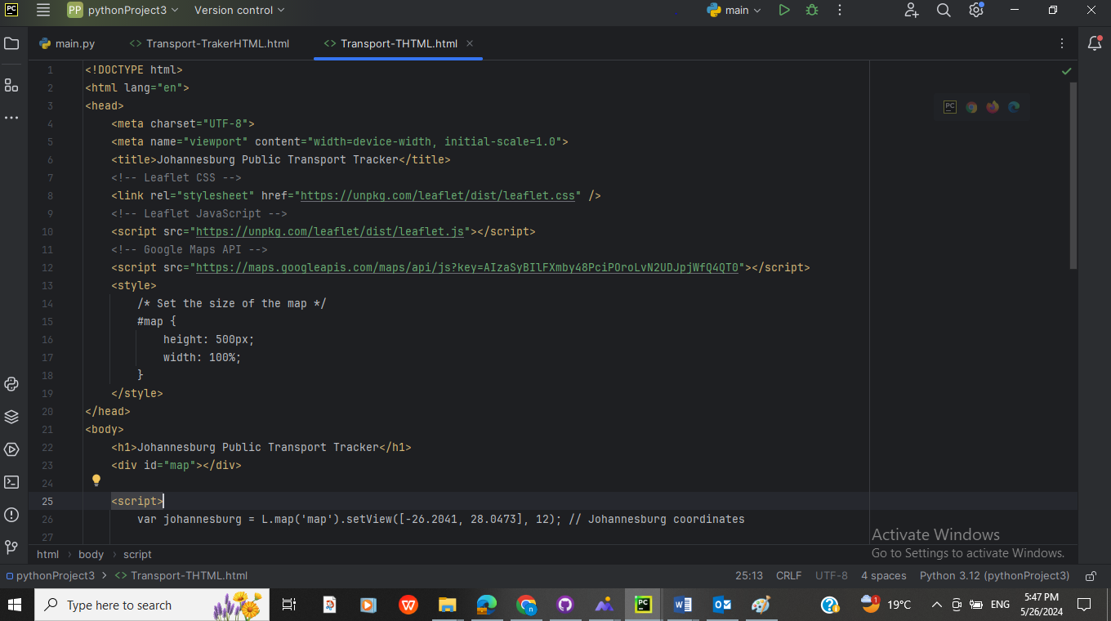

**Testing and Optimization**

**Local Testing:**

A local server or development environment was used for local testing and to ensure that the local URL (http://localhost:8080) is included in your API key restrictions.

**Version Control with GitHub**

A GitHub repository for your geospatial application to manage version control

**GitHub link**: **https://github.com/CodeConquerorNN/JHB-Tracker/blob/a2f6363620fc8ce6ea2a076da540cae1231b1e03/pythonProject3/Transport-TrakerHTML.html2**

